Stolen bases
The official scorer shall credit a stolen base to a runner whenever the runner advances one base unaided by a hit, a putout, an error, a force-out, a fielder’s choice, a passed ball, a wild pitch or a balk [OBR 9.07].
The abbreviation for stolen base is “SB” followed by the batting order number of the player at bat at the time of the stolen base. The stolen base occurred when the pitcher was still making his wind-up, and the runner reached the next base before or during the pitch was made.
When a hit is made to fair territory during an attempted steal, regardless of whether the hit is safe or other developments intervene, ther unner’s advance must be considered as being made on the hit, rather than being a stolen base. The same applies to forced runners, when the batter is awarded first base on a base on balls, hit batter, interference or obstruction.
An attempt to steal must be made in the window of time that begins with the pitcher on the mound, and ends when the ball is dead, or is once again in possession of the pitcher on his plate.
Example 83, if, with runners on first and third, the catcher throws to first in an attempt to catch the runner off base, and the runner on third takes advantage of this to reach home base, the latter runner must be credited with a stolen base.
WBSC |  | Traduction dans l’outil de scorage |  | Outil
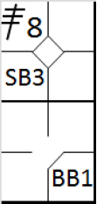 |  | /* Le premier batteur frappe un triple dans le champ centre */  action { batter -> 3B8 }  /* Le batteur suivant gagne la première base sur un 'base on ball' */  action { batter -> BB }  /* Le coureur en 3 vole le marbre */  action { runner3 -> SB } |  | 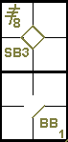
A stolen base must also be awarded in the following cases:
- When a runner starts for the next base before the pitcher delivers the ball and the pitch results in … a wild pitch or passed ball [OBR 9.07(a)].

Example 84: If the runner succeeds in advancing just one base, he should be credited with a stolen base. If he succeeds in advancing an additional base, he should be credited with as tolen base for the first base, and a wild pitch or passed ball for the additional base.
WBSC |  | Traduction dans l’outil de scorage |  | Outil
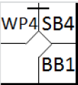 |  | /* Le premier batteur arrive sur base sur un 'base on ball' */  action { batter -> BB }  /* Il vole la deuxième base et profite d'un lancer fou pour atteindre la troisième base */  action { runner1 -> SB WP } |  | 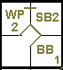
- When a runner is attempting to steal, and the catcher, after receiving the pitch, makes a wild throw trying to prevent the stolen base [OBR9.07(b)].

Example 85: In this case a stolen base is credited to the runner, and no error is charged to the catcher,
WBSC |  | Traduction dans l’outil de scorage |  | Outil
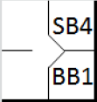 |  | /* Le premier batteur arrive sur base sur un 'base on ball' */  action { batter -> BB }  /* Il vole la deuxième base */  action { runner1 -> SB } |  | 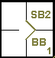

Example 86: … unless the runner succeeded in advancing an additional base, in which case the catcher should be charged with an extra base error.
WBSC |  | Traduction dans l’outil de scorage |  | Outil
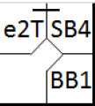 |  | /* Le premier batteur arrive sur base sur un 'base on ball' */  action { batter -> BB }  /* Il vole la deuxième base et profite d'une erreur pour gagner la troisième base */  action { runner1 -> SB e2T } |  | 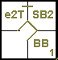
- When a runner, attempting to steal, or after being picked off base, evades being put out in a run-down play and advances to the next base without the aid of an error [OBR 9.07(c)].
- If another runner also advances on the play, the official scorer shall credit both runners with stolen bases [OBR 9.07(c)].

Example 87: All of these runners should be credited with stolen bases.
WBSC |  | Traduction dans l’outil de scorage |  | Outil
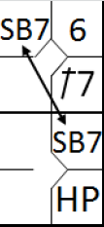 |  | /* Le premier batteur frappe un simple dans le champ gauche */  action { batter -> 1B7 }  /* Le batteur suivant la première base sur un 'Hit by pitch', le coureur avance */  action { batter -> HP, runner1 -> + }  /* Les deux coureurs volent une base */  action { runner1 -> SB, runner2 -> SB } |  | 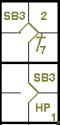

Example 88: …unless one of them is put out (or would have been put out but for a fielding error), in which case the other runners are credited with a fielder’s choice.
In this case, put an arrow between the two notations to indicate that caught stealing and fielder’s choice occurred inone play.
WBSC |  | Traduction dans l’outil de scorage |  | Outil
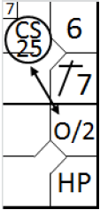 |  | /* Le premier batteur frappe un simple dans le champ gauche */  action { batter -> 1B7 }  /* Le batteur suivant la première base sur un 'Hit by pitch', le coureur avance */  action { batter -> HP, runner1 -> + }  /* Les deux coureurs volent une bas, mais le plus avancé se fait retirer */  action { runner1 -> O/2, runner2 -> CS25 } |  | 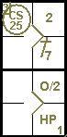

- If a runner advances while another runner, attempting to steal, evades being put out in a run-down play and returns safely, without the aid of an error, to the base he originally occupied[OBR 9.07(c)].
In this case the runner is credited with a stolen base. If the other runner is put out, however, the runner who advanced is credited with a fielder’s choice (O/.).
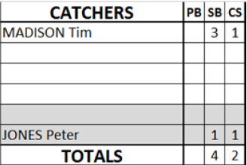 | Every stolen base is credited to the runner who stole the base, and this is done by scoring a vertical stroke in the appropriate column on the offensive score sheet, next to the player’s name. The same notation is used in the catcher’s table (stolen bases conceded), provided that the fielder on home base had the opportunity to oppose the action, or that, at the time of the attempted steal, a legal pitch was delivered.
In the event that a stolen base is credited as a result of being picked off base, the stolen base should be credited to the pitcher. Write the name of the pitcher in a colored row of the catcher box and put a vertical stroke behind this name. By doing this the sum of the stolen bases will be the same as the sum of stolen bases in the offense information.
Stolen bases should not be credited in the following cases:
- When a runner is tagged out after over sliding a base, while attempting either to return to that base or to advance to the next base [OBR9.07(e)].
The runner is “caught stealing” instead.
ATTENTION: If the runner overruns the base he was attempting to steal and is tagged out, he is charged with the stolen base and called out.
- When in the scorer’s judgment a runner attempting to steal is safe because of a muffed throw [OBR 9.07(f)].

Example 89: In this case the runner is charged with “caught stealing”, an error is charged to the fielder who muffed the Throw and an assist and the caught stealing are credited to the fielder who made the throw.
WBSC |  | Traduction dans l’outil de scorage |  | Outil
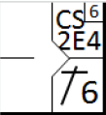 |  | /* Le premier batteur frappe un simple sur l'arrêt court */  action { batter -> 1B6 }  /* le coureur tente de vol la deuxième, et il aurait été retiré si le défenseur de la deuxième n'avait pas commit une erreur */  action { runner1 -> CS2E4 } |  | 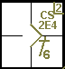
- The official scorer shall not score a stolen base when a runner advances solely because of the defensive team’s indifference to the runner’s advance [OBR 9.07(g)].

Example 90: Despite having seen that the runner on first is attempting to steal a base, the catcher makes no attempt to oppose it. The official scorer judges that there is no legitimate strategic motive not to make the throw, so it is a defensive indifference (undefended steal). The runner advances to second and the play is therefore recorded with “O/2”. This is also explained in OBR [9.07(g) Comment]
WBSC |  | Traduction dans l’outil de scorage |  | Outil
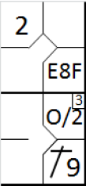 |  | /* Le premier frappeur frappe une fly dans le champ centre, le défenseur commet une erreur en essayant de la rattraper */  action { batter -> E8F }  /* Le batteur suivant frappe un hit dans le champ droit, le coureur gagne deux bases */  action { batter -> 1B9 , runner1 -> ++ }  /* le coureur en 1 tente de voler la base, la défense reste indifférente */  action { runner1 -> O/2 } |  | 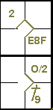
If the catcher does not try to put out the runner attempting to steal but instead attempts another play, such as throwing to the pitcher or the second baseman who has come forward, or to the third baseman, with a view to picking off the runner on third base or making him advance, a stolen base is credited to the runner who advanced.
Unless the attempt to make the runner on third advance succeeds and he is put out, in which case a caught stealing is credited to the runner on third base, and a fielder’s choice to the runner who reached second.
NOTE: If the runner did not try to advance but was put out returning to third base, he is not charged with “caught stealing”.
ATTENTION: When a rundown play fails without any errors being committed, and the runner returns to the base he previously occupied, nothing is recorded on the score report. If, on the other hand, the runner returns because of an error, the assist, the error and caught stealing must all be noted.
At this point, it is worth concluding the section on stolen bases with some specific examples.
Example 91: With first and third bases occupied the runner on first tries to steal second base. The catcher throws to second in an attempt to put him out. The runner on third, seeing this, sets off to steal home base. If the runner who tried to steal second base also reaches base safely, both runners are credited with stolen bases.
WBSC |  | Traduction dans l’outil de scorage |  | Outil
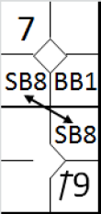 |  | /* Le premier batteur arrive sur base sur un 'base on ball' */  action { batter -> BB }  /* Le batteur suivant frappe un simple dans le champ droit, le coureur gagne deux bases */  action { batter -> 1B9 , runner1 -> ++ }  /* Le deux coureurs volent une base */  action { runner1 -> SB , runner3 -> SB } |  | 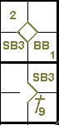

Example 92: If, on the other hand, the runner who tries to steal second is put out (or would have been put out if not for an error), he is charged with “caught stealing”, and the other runner’s run is counted as a fielder’s choice.
WBSC |  | Traduction dans l’outil de scorage |  | Outil
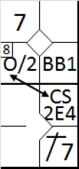 |  | /* Le premier batteur arrive sur base sur un 'base on ball' */  action { batter -> BB }  /* Le batteur suivant frappe un simple dans le champ gauche, le coureur gagne deux bases */  action { batter -> 1B7 , runner1 -> ++ }  /* Le deux coureurs volent une base, mis le coureur en 1 aurait du être retiré*/  action { runner1 -> CS2E4 , runner3 -> O/2 } |  | 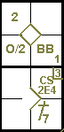

Example 93: With runners on first and second, the runner on second base tries to steal third. The pitch turns out to be wild and in consequence the runner on first reaches second. In this case a stolen base is credited to the runner who reached third base, and an advance by wild pitch is credited to the other runner, who would not have reached second base without it.
WBSC |  | Traduction dans l’outil de scorage |  | Outil
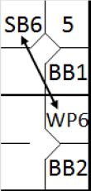 |  | /* Le premier batteur arrive sur base sur un 'base on ball' */  action { batter -> BB }  /* Le batteur suivant arrive sur base sur un 'base on ball', le coureur gagne une base */  action { batter -> BB , runner1 -> + }  /* Le coureur en 2 volent une base, le coureur en une prend la 2 sur un lancer fou */  action { runner1 -> WP , runner2 -> SB } |  | 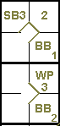

Example 94: With runners on first and third, the runner on first base tries to steal second. The catcher muffs his throw to second and the runner on third takes the opportunity to scorea run. The runner on first base is credited with a stolen base, and the advance by the runner on third is put down to an extra base error by the catcher.
WBSC |  | Traduction dans l’outil de scorage |  | Outil
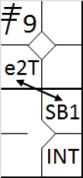 |  | /* Le premier batteur arrive sur base sur un triple dans le champ gauche */  action { batter -> 3B9 }  /* Le premier batteur arrive sur base sur une interférence du catcheur */  action { batter -> INT }  /* Le coureur vole la deuxième base, le receveur relai pour évite le vol mais fait une erreur de lancer, le coureur en 3 en profite pour marquer un point */  action { runner1 -> SB , runner3 -> e2T } |  | 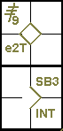

Example 95: The runner on third is trapped between third and home base, but succeeds in reaching home base safely without any errors being committed by the defense. He is credited with a stolen base.
WBSC |  | Traduction dans l’outil de scorage |  | Outil
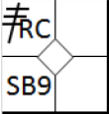 |  | /* Le premier batteur arrive sur base sur un triple dans le champ droit */  action { batter -> 3BRC }  action { runner3 -> SB } |  | 

Example 96: With runners on first and second, there is a double steal. The catcher, rather than playing for the runner on second, plays for the runner on first, and when he throws the preceding runner scores. The advance to home base is also a stolen base, and the connecting line indicates the continuity of action.
WBSC |  | Traduction dans l’outil de scorage |  | Outil
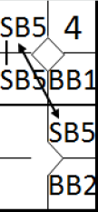 |  | /* Le premier batteur arrive sur base sur un 'base on ball' */  action { batter -> BB }  /* Le batteur suivant arrive sur base sur un 'base on ball', le coureur gagne une base */  action { batter -> BB , runner1 -> + }  /* Le coureur en 2 et 1 volent une base, le coureur arrivant en 3en profite pour voler une deuxième base */  action { runner1 -> SB , runner2 -> SB SB } |  | 